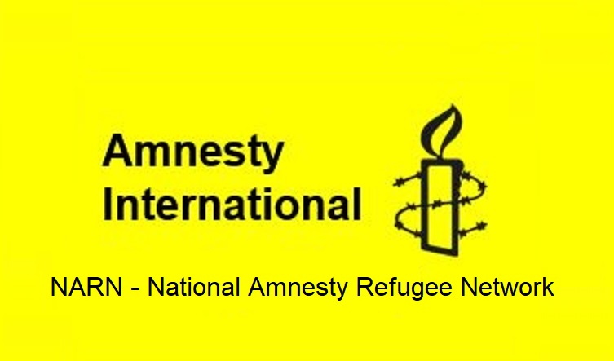
Refugee Sector Letter Blitz

March 2022:
Increase the Intake of Afghan Refugees Supported by ARAN, RAR, G4R, & NARN

Available to download at: https://www.ruralaustraliansforrefugees.org.au/rar-groups/online-group/

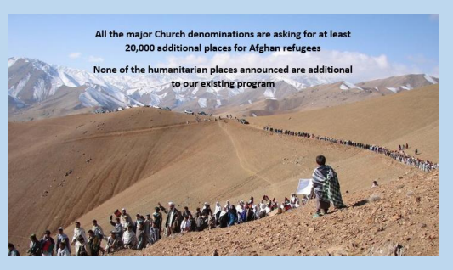

Included in this kit is the information you need to create your own letters

- Guide and Background notes prepared by ARAN’s Letter Writing Network.
- 2 sample letters to personalise and send.
- Postal Addresses for MPs and Senators
- Email addresses for MPs and Senators

NOTE: If you are sending an email be sure to include your NAME and ADDRESS
The Subject line of your email could be - CALL TO ACTION: Increase the Intake of Afghan Refugees

Personalised letters and emails are best
~~~~~~~~~~~~~~~~~~~~~~~~~~~~~~~~~
Regards,
The ARAN Letter Writing Network
austrefugeenetwork@gmail.com

KEY REQUESTS

We are calling on the Australian Government to:

- Commit to an additional humanitarian intake of at least 20,000 refugees prioritising the most vulnerable persecuted people of Afghanistan

- Grant permanent protection to all people from Afghanistan who are in Australia on temporary protection visas or currently awaiting application outcomes

- Reunite Afghan families by making immediate arrangement to bring the families of refugees from Afghanistan to Australia

- Lift the ban on resettlement of refugees to Australia through the UNHCR in Indonesia

- Provide additional resources to the Department of Home Affairs immigration and settlement services, to ensure the continued processing of claims from other refugee communities

BACKGROUND INFORMATION

Choose 2 or 3 dot points to use in your letter. Write these in your own words to support the key requests.

- The return of the Taliban in Afghanistan following the withdrawal of the US, Australian and other military support left thousands of Afghans at immediate risk of torture and death - particularly those who had assisted the western forces, and the persecuted Hazara minority.

- Members of the Hazara community in Australia hold grave fears for the safety of their family members who are great risk of being targeted by the Taliban. They urgently need the Australian government to bring their relatives to safety in Australia.

- There is strong community support in Australia for accepting refugees from Afghanistan.

  - 300 organisations, businesses and community groups signed a joint letter from the Refugee Council of Australia urging our government to commit to 20,000 additional humanitarian places.

  - Action for Afghanistan, an Afghan-Australian advocacy coalition, was established to call for:
    - A special humanitarian intake of 20,000
    - Immediate resettlement of those who had assisted the Western forces
    - Granting permanent resettlement to over 5,000 Hazara refugees already in Australia
    - Granting amnesty to all nationals of Afghanistan currently in Australia who fear returning
    - Prioritising family reunion for refugees from Afghanistan
    - Lifting the ban on resettlement for refugees stranded in Indonesia, including up to 10,000 refugees from Afghanistan

  - Since August 2021, there has been constant lobbying, with delegations to Minister Hawke from representatives of the Afghan-Australian community, Veterans, faith groups, and the wider Australian community, requesting a substantial increase in the intake of Afghan refugees.

- Immediately after the collapse of Kabul in August 2021, Australia offered 3,000 places for Afghan refugees from within Australia’s existing allocation in the humanitarian intake program - no additional places. Prime Minister Morrison gave assurances that this number was a ‘floor, not a ceiling.’

- It is not at clear how many refugees from Afghanistan have been given visas. Many thousands of applications have been lodged, but the outcomes of these applications have not been advised.

- In January 2022 Immigration Minister Alex Hawke announced that Australia would take 15,000 Afghans over four years. It was published as being additional places - However, these 15,000 places are:

  - 5,000 places in the family reunion stream that has always existed and where the government carries no cost; and,
  - 10,000 places over four years from within the existing humanitarian intake - that is: 2,500 visas each year - no additional places.

- During its term of office, the Morrison Government has reduced Australia’s annual Humanitarian Intake from 18,000 to 13,750. This reduction is unnecessary, and we know that many refugees wait for years for resettlement. Australia should be offering more resettlement places.

- The humanitarian situation in Afghanistan is dire with:
  - 14 million at risk of food insecurity
  - 2.5 million people seeking refuge in neighbouring countries
  - Over half a million internally displaced
  - A severe protracted drought and the COVID-19 pandemic exacerbating crisis conditions.

- There are about 4,300 Afghans in Australia on temporary protection visas, and more than 50 remaining in immigration detention. People on temporary visas do not have the security of permanent protection, and have no right to apply for family reunion. The only assurance that the Australian government has given Afghans in Australia on temporary protection visas is that they will not be sent back to Afghanistan ‘at this time’.

- Since 2014, Australia has banned the resettlement of refugees through the UNHCR in Indonesia. This has limited the resettlement options of the over 10,000 Afghan refugees (many of whom have family in Australia) trapped in Indonesia.

- There is a call for a special humanitarian intake as there was in response to the Syrian crisis.

- https://www.theguardian.com/australia-news/2014/nov/18/asylum-seekers-registered-with-unhcr-in-indonesia-blocked-from-resettlement
- https://www.micahaustralia.org/tim_costello_australia_shamefully_shirking_taking_its_fair_share_of_afghan_refugees
- https://www.refugeecouncil.org.au/15000-places-for-afghan-nationals-over-four-years-why-australians-are-disappointed/

Addresses for your letters:

- The Prime Minister
Prime Minister
PO Box 6022
House of Representatives
Parliament House
Canberra ACT 2600

You cannot email the PM. Use the following link to the PM’s Contact Form.
https://www.pm.gov.au/contact-your-pm

- Alex Hawke Minister for Immigration
The Hon Alex Hawke,
Minister for Immigration, Citizenship, Migrant Services & Multicultural Affairs
PO Box 1173
Castle Hill NSW 1765

Use the following link to the Email Contact Form for Alex Hawke:
https://www.aph.gov.au/Senators_and_Members/Contact_Senator_or_Member?MPID=HWO

- The Hon Karen Andrews Minister for Home Affairs
The Hon Karen Andrews
Minister for Home Affairs
PO Box 409
Varsity Lakes QLD 4227
Email: Karen.Andrews.MP@aph.gov.au

You may also like to send emails to:
- Shadow Minister of Home Affairs Kristina Keneally senator.keneally@aph.gov.au
- Greens Senator Nick McKim senator.mckim@aph.gov.au
- Crossbench Senators:
TAS senator.lambie@aph.gov.au; SA senator.patrick@aph.gov.au; SA senator.griff@aph.gov.au

Canberra Postal Address for all Senators
PO Box 6100
Senate,
Parliament House
Canberra ACT 2600
Canberra Postal Address for all MPs
PO Box 6022
House of Representatives
Parliament House
Canberra ACT 2600

Find your MP - enter your postcode in the ‘Search Member’ section

Email addresses for all Senators are on the next page

Email addresses for all Senators - 12 Nov 2021

Email addresses for all ACT senators - ready to copy and paste into “TO” section of your email:
senator.katy.gallagher@aph.gov.au; senator.seselja@aph.gov.au

Email addresses for all NSW senators - ready to copy and paste into “TO” section of your email:
senator.ayres@aph.gov.au; senator.bragg@aph.gov.au; senator.davey@aph.gov.au;
senator.faruqi@aph.gov.au; senator.fierravanti-wells@aph.gov.au; senator.hughes@aph.gov.au;
senator.keneally@aph.gov.au; senator.mcallister@aph.gov.au; senator.molan@aph.gov.au;
senator.oneill@aph.gov.au; senator.payne@aph.gov.au; senator.sheldon@aph.gov.au;

Email addresses for all NT senators - ready to copy and paste into “TO” section of your email:
Senator.McCarthy@aph.gov.au; senator.mcmahon@aph.gov.au

Email addresses for all Queensland senators - ready to copy and paste into “TO” section of your email:
senator.canavan@aph.gov.au; senator.chisholm@aph.gov.au; senator.green@aph.gov.au;
senator.hanson@aph.gov.au; senator.mcdonald@aph.gov.au; senator.mcgrath@aph.gov.au;
senator.rennick@aph.gov.au; senator.roberts@aph.gov.au; senator.scarr@aph.gov.au;
senator.stoker@aph.gov.au; senator.waters@aph.gov.au; senator.watt@aph.gov.au;

Email addresses for all SA senators - ready to copy and paste into “TO” section of your email:
senator.antic@aph.gov.au; senator.birmingham@aph.gov.au; senator.farrell@aph.gov.au;
senator.fawcett@aph.gov.au; senator.griff@aph.gov.au; senator.grogan@aph.gov.au;
senator.hanson-young@aph.gov.au; senator.mclachlan@aph.gov.au; senator.patrick@aph.gov.au;
senator.ruston@aph.gov.au; senator.marielle.smith@aph.gov.au; senator.wong@aph.gov.au;

Email addresses for all Tasmania senators - ready to copy and paste into “TO” section of your email:
senator.abetz@aph.gov.au; senator.askew@aph.gov.au; senator.bilyk@aph.gov.au;
senator.carol.brown@aph.gov.au; senator.chandler@aph.gov.au; senator.colbeck@aph.gov.au;
senator.duniam@aph.gov.au; senator.lambie@aph.gov.au; senator.mckim@aph.gov.au;
senator.polley@aph.gov.au; senator.urquhart@aph.gov.au; senator.whish-wilson@aph.gov.au;

Email addresses for all Victorian senators - ready to copy and paste into “TO” section of your email:
senator.carr@aph.gov.au; senator.ciccone@aph.gov.au; senator.henderson@aph.gov.au; senator.hume@aph.gov.au; senator.kitching@aph.gov.au; senator.mckenzie@aph.gov.au;
senator.mirabella@aph.gov.au; senator.paterson@aph.gov.au; senator.rice@aph.gov.au;
senator.thorpe@aph.gov.au; senator.walsh@aph.gov.au; senator.van@aph.gov.au;

Email addresses for all WA senators - ready to copy and paste into “TO” section of your email:
senator.brockman@aph.gov.au; senator.cash@aph.gov.au; senator.cox@aph.gov.au
senator.dodson@aph.gov.au; senator.lines@aph.gov.au; senator.matt.o'sullivan@aph.gov.au; senator.pratt@aph.gov.au; senator.reynolds@aph.gov.au; senator.small@aph.gov.au;
senator.smith@aph.gov.au; senator.steele-john@aph.gov.au; senator.sterle@aph.gov.au

NOTE: If you are sending an email be sure to include your NAME and ADDRESS

Email addresses for MPs and Senators - https://aran.net.au/resources/letter-writing/

The Subject line of your email could be - CALL TO ACTION: Increase the Intake of Afghan Refugees

PROFORMA LETTERS … … … … … Increase the Intake of Afghan Refugees

LETTER 1. The Hon Alex Hawke, Minister for Immigration

The Hon Alex Hawke,
Minister for Immigration, Citizenship, Migrant Services & Multicultural Affairs
PO Box 1173
Castle Hill NSW 1765

Dear Minister Hawke,

I am writing to endorse the call of the many delegations you have received to increase Australia’s intake of refugees from Afghanistan.

In August 2021 the Prime Minister assured Australians that the offer of 3000 places was ‘a floor, not a ceiling’. Despite months of pleading from Veterans, faith leaders, the Afghan-Australian and wider Australian community for a much more substantial response, there was no further announcement for 5 months.

Finally in January the Government announced an allocation of 15,000 places over 4 years for Afghan refugees, providing just 2,500 places per year from the existing humanitarian refugee quota.

Given the humanitarian crisis and increasing displacement in Afghanistan, this is extremely disappointing. Also, it remains unclear just how many visas have been provided for people fleeing Afghanistan since August last year.

Since August 2021, the Australian community has demonstrated its strong support for a more generous response to people fleeing the Taliban. The resettlement of a special intake of refugees is well within Australia’s capacity. The Afghan-Australian community, the Veterans community, church groups, a strong refugee support network, and the wider community are ready to help. After 20 years of interventions and promises, Australia owes it to the people of Afghanistan to respond more generously.

I therefore call on the Morrison Government, and you as Minister for Immigration, to heed Australia’s moral obligation to Afghan nationals fleeing the Taliban and:

- Commit to an additional intake of at least 20,000 refugees most at risk from the Taliban

- Grant permanent protection to all people from Afghanistan in Australia on temporary protection visas or currently awaiting application outcomes

- Reunite Afghan families by making immediate arrangement to bring the families of refugees from Afghanistan to Australia

- Lift the ban on resettlement of refugees to Australia through the UNHCR in Indonesia

- Provide additional resources to the Department of Home Affairs immigration and settlement services, to ensure the continued processing of claims from other refugee communities.

Yours sincerely,

Name:
Address:

LETTER 2. Letter to your local MP

…………………….. [Fill in your local MP’s name]

Member for …. [Fill in your Electorate]

Dear …………. [Fill in your local MP’s name]

I am writing to endorse the call of the numerous delegations to Minister for Immigration Alex Hawke to provide a special intake of 20,000 refugees from Afghanistan.

Since August 2021, the Australian community has demonstrated its strong support for a more generous response to people fleeing the Taliban. The resettlement of a special intake of refugees is well within Australia’s capacity. The Afghan-Australian community, the Veterans community, church groups, a strong refugee support network, and the wider community are ready to help.

After 20 years of interventions and promises, Australia owes it to the people of Afghanistan to respond more generously.

In August 2021 the Prime Minister assured Australians that the offer of 3000 places was ‘a floor, not a ceiling’. Despite months of pleading from Veterans, faith leaders, the Afghan-Australian and wider Australian community for a much more substantial response, there was no further announcement for 5 months.

Finally in January the Government announced an allocation of 15,000 places over 4 years for Afghan refugees, providing just 2,500 places per year from the existing refugee quota.

Given the humanitarian crisis and increasing displacement in Afghanistan, this is extremely disappointing. Also, it remains unclear just how many visas have been provided for people feeling Afghanistan since August last year.

As your constituent, I therefore call on you to raise this with Minister Hawke as a matter of urgency, and urge him to acknowledge Australia’s moral obligation to Afghan nationals fleeing the Taliban, and to:

- Commit to an additional intake of at least 20,000 refugees most at risk from the Taliban

- Grant permanent protection to all people from Afghanistan in Australia on temporary protection visas or currently awaiting application outcomes

- Reunite Afghan families by making immediate arrangement to bring the families of refugees from Afghanistan to Australia

- Lift the ban on resettlement of refugees to Australia through the UNHCR in Indonesia

- Provide additional resources to the Department of Home Affairs immigration and settlement services, to ensure the continued processing of claims from other refugee communities.

Yours sincerely,

Name:
Address:

