Refugee Sector Letter Kit

Supported by ARAN, RAR, GFR, & NARN
Issue for April 2024
A call for sound, fair and effective legislation

Available to download at –
- https://aran.net.au/resources/letter-writing/
- https://ruralaustraliansforrefugees.org.au/write-a-letter

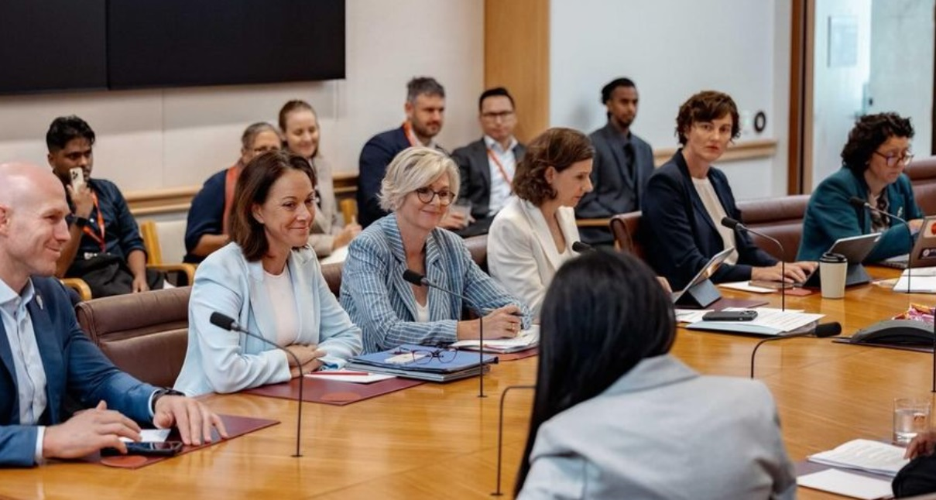
Photo courtesy of Canberra RAC

Included in this kit is the information you need to create your own letters or use the proformas

- Guide and Background notes prepared by ARAN’s Letter Writing Network.
- Postal Addresses for MPs and Senators
- Email addresses for MPs and Senators
- A proforma letter that you can copy (and personalise) to send by post or email.

Personalised letters are best –

- You might like to use the AIDA principle

  - A - Attention - grab the recipient's attention. Say something positive about the reader that is directed towards the focus of your letter. Stimulate the recipient's curiosity
  - I - Interest & Information- encourage the recipient to read on.
  - D - Desire - Getting the reader to want to do what you are seeking - in their interest to do so.
  - A - Action- inform the reader of the action you want them to take.

~~~~~~~~~~~~~~~~~~~~~~~~~~~~~~~~~~~~~
Regards,
The ARAN Letter Writing Network
austrefugeenetwork@gmail.com
A call for sound, fair and effective legislation

Why it is important to write about this now
The Australian High Court’s November 2023 ruling on the indefinite detention of people awaiting deportation resulted in the release of 149 people from immigration detention. The Albanese Government has created unwarranted public fear and hysteria by reinforcing the Coalition’s false claims that the released detainees are all ‘hardened criminals’, and pose a grave threat to community safety.
The Government’s response to the High Court decision has been to introduce 3 pieces of rushed and ill-considered legislation, aiming to give the government the means to circumvent the High Court decision. This series of legislation imposes unfair punitive conditions on people who are released from immigration detention as a consequence of this High Court ruling, and gives extraordinary unfettered power to the immigration minister.
None of the people subject to this legislation were serving a criminal sentence when they were released. They were released from immigration detention, which is meant to be for administrative purposes only. Those who had been convicted of crimes in the past had already served their court-imposed sentences, and were subsequently taken into immigration detention awaiting deportation.
We must send a message to government, and especially our local Labor MPs and Senators that voters expect Parliament to deliver sound, fair and effective policy and legislation. Good governance must take priority over political point scoring.
BACKGROUND
High Court decision
In November 2023 the High Court of Australia handed down a unanimous decision in the case of NZYQ vs Minister for Immigration, Citizenship and Multicultural Affairs that indefinite immigration detention of non-citizens is unlawful and unconstitutional when there is no prospect of them being deported. The basis of this ruling is that indefinite detention in such cases amounts to punishment. According to the doctrine of separation of powers, adjudicating and punishing people for crimes is the role of courts, not the executive branch of government.
Government response - 3 pieces of legislation
Migration Amendment (Bridging Visa Conditions) Bill 2023, passed through the House and Senate in Nov 2023.
Under this legislation, all people released from indefinite immigration detention as a consequence of this ruling are subject to severe visa conditions such as electronic monitoring, curfews, and restrictions on their movements and contact with others. Breach of these visa restrictions is a criminal offence, punishable by a mandatory minimum 12 months sentence. Breach of vias conditions has never before been a criminal offence.
Migration and Other Legislation Amendment (Bridging Visas, Serious Offenders and Other Measures) Act 2023, passed through the House and Senate in Dec 2023.
This is the Preventive Detention bill. Its aim is to give the Minister the power to place any of those released back in detention. Under this ‘community safety order’ regime, the Minister for Home Affairs or the Minister for Immigration can apply to a court to re-detain for up to 3 years a person who was convicted of certain violent or sexual crimes (either in Australia or another country), and is deemed to pose an unacceptable risk of committing a similar offence in the future.
Migration Amendment (Removal and Other Measures) Bill 2024, passed in the House in March 2024 but failed in the Senate and was referred to a Senate Inquiry due to report on 7 May 2024.
This proposed legislation makes it a criminal offence for a non-citizen to not cooperate in their deportation process, such as failure to sign forms, provide documents or attend interviews. Failure to cooperate carries a mandatory prison sentence of 1-5 years, and a possible fine of over $90,000.
This Bill also gives the Minister the power to designate as a ‘removal concern country’ any country that does not accept involuntary return of their citizens. The Minister can then ban all visa applications from any citizen of that country.
The Bill also gives the Minister a new power to revoke refugee status.
If passed, this legislation would affect
- people currently in detention, and
- people living in the community on certain bridging visas who are not eligible for any other visa to stay in Australia. This can include people who have been found to be refugees.
Objections to Government Response
- The legislation was rushed through Parliament, with no proper Parliamentary scrutiny, and little clarity about how it will actually work.
- The visa restrictions and obligations placed on released detainees are disproportional to any actual assessed risk to community safety. The conditions are far harsher than ordinary parole or bail, and are based on a politically concocted story that all those released from detention pose an immediate and serious threat to community safety.
- Serious restrictions of liberty are imposed on certain people simply because of their visa status. Those who had committed criminal offences in the past had served their sentence. These visa restrictions amount to another punishment. This could breach the doctrine of Constitutional Separation of Powers: it is not the role of the Executive Branch of government to judge and punish; that is the role of the Judicial Branch.
- The Minister is given more sweeping powers, such as revoking refugee status, designating ‘removal concern countries’ and banning all visa applications from those countries.
- If passed, the Removals Bill will apply to people whose asylum claims failed under the Fast Track Assessment process. There are up to 10,000 people living in the community in this situation. The Albanese Government has acknowledged the Fast Track Assessment process as essentially inadequate and unfair, and has moved to abolish it from 1 July 2024. Yet they are still introducing legislation which further penalises those people whose protection claims have never been fairly heard.
We are calling on the government to change its approach to responding to the High Court decision:
- Respect the spirit of the High Court Decision that indefinite immigration detention is illegal and unconstitutional.
- Reject the Opposition’s fear-mongering about community safety.
- As a matter of urgency, commit to reconsideration of claims rejected under the Fast Track Assessment process, and allow fresh applications taking into account changed circumstances in countries such as Iran, Afghanistan, Pakistan and Myanmar.
- Allow people disadvantaged by the Fast Track system to apply for other visas (such as partner visas for those who share their lives with partners who have permanent residency)
- Declare a moratorium on deportation of refugees and asylum seekers until such time as their claims have been properly determined and/or reviewed under a new, fair review process
- Take advantage of the opportunity provided by the High Court decision to continue developing fair and humane immigration policy as the Albanese Government promised at the time of its election.
- In compliance with the High Court ruling, continue to work towards ending mandatory indefinite immigration detention.
For further information:
- https://www.hrlc.org.au/reports-news-commentary/2023/11/29/explainer-high-court-ruling-in-nzyq
- https://www.hrlc.org.au/reports-news-commentary/2023/11/17/summary-migration-amendment-bridging-visa-conditions-bill-2023
- https://www.hrlc.org.au/reports-news-commentary/preventative-detention
- https://www.hrlc.org.au/reports-news-commentary/2024/03/26/indefinite-detention
- https://www.thesaturdaypaper.com.au/news/law-crime/2024/03/23/labor-settling-asylum-cases-avoid-high-court-actions
- https://www.smh.com.au/politics/federal/albanese-promised-a-better-way-on-borders-he-s-doing-it-howard-s-way-20240327-p5ffjz.html
- https://www.unsw.edu.au/news/2024/03/Kaldor-Centre-statement-deportation-bill
- https://www.abc.net.au/news/2024-04-02/labor-senators-join-critcism-of-rushed-immigration-legislation/103656282
- https://theconversation.com/new-laws-to-deal-with-immigration-detainees-were-rushed-leading-to-legal-risks-219384
- https://www.canberratimes.com.au/story/8571118/abul-rizvi-why-labor-rushed-new-immigration-powers/
- https://www.sydneycriminallawyers.com.au/blog/draconian-refugee-deportation-laws-carry-all-the-hallmarks-of-albaneses-howard-era/
Who to write to:

We suggest you write to

- The Prime Minister, Anthony Albanese
Contact Form: https://www.pm.gov.au/contact-your-pm

- Attorney General, Mark Dreyfus
Contact Form: https://www.aph.gov.au/Senators_and_Members/Contact_Senator_or_Member?MPID=HWG

- Minister for Home Affairs, Clare O’Neil
Email: Clare.ONeil.MP@aph.gov.au

- Minister for Immigration, Andrew Giles
Contact Form: https://www.aph.gov.au/Senators_and_Members/Contact_Senator_or_Member?MPID=243609

Plus your local member if Labor/Greens/Progressive Independent - if Coalition - then Labor Senators in your state)

Addresses for your letters:

Canberra Postal Address for all SENATORS
PO Box 6100
Senate,
Parliament House
Canberra ACT 2600
Canberra Postal Address for all MPs
PO Box 6022
House of Representatives
Parliament House
Canberra ACT 2600

Find electorate postal and email addresses for your local Labor MP here: https://www.aph.gov.au/senators_and_members/members

Email Addresses for ALL Senators - updated March 2024
NB - For your convenience - Labor Party Senators are listed in RED

Email addresses for all ACT senators - ready to copy and paste into “TO” section of your email:
senator.katy.gallagher@aph.gov.au; Senator.David.Pocock@aph.gov.au

Email addresses for all NSW senators - ready to copy and paste into “TO” section of your email:
senator.ayres@aph.gov.au; senator.bragg@aph.gov.au; senator.cadell@aph.gov.au; senator.davey@aph.gov.au;
senator.faruqi@aph.gov.au; senator.hughes@aph.gov.au; senator.kovacic@aph.gov.au; senator.mcallister@aph.gov.au; senator.oneill@aph.gov.au; senator.sharma@aph.gov.au; senator.sheldon@aph.gov.au; senator.shoebridge@aph.gov.au

Email addresses for all NT senators - ready to copy and paste into “TO” section of your email:
Senator.McCarthy@aph.gov.au; senator.nampijinpaprice@aph.gov.au

Email addresses for all Queensland senators - ready to copy and paste into “TO” section of your email:
senator.allman-payne@aph.gov.au; senator.canavan@aph.gov.au; senator.chisholm@aph.gov.au; senator.green@aph.gov.au;
senator.hanson@aph.gov.au; senator.mcdonald@aph.gov.au; senator.mcgrath@aph.gov.au; senator.rennick@aph.gov.au;
senator.roberts@aph.gov.au; senator.scarr@aph.gov.au; senator.waters@aph.gov.au; senator.watt@aph.gov.au

Email addresses for all SA senators - ready to copy and paste into “TO” section of your email:
senator.antic@aph.gov.au; senator.birmingham@aph.gov.au; senator.farrell@aph.gov.au; senator.fawcett@aph.gov.au;
senator.grogan@aph.gov.au; senator.hanson-young@aph.gov.au; senator.liddle@aph.gov.au; senator.mclachlan@aph.gov.au;
senator.pocock@aph.gov.au; senator.ruston@aph.gov.au; senator.marielle.smith@aph.gov.au; senator.wong@aph.gov.au

Email addresses for all Tasmania senators - ready to copy and paste into “TO” section of your email:
senator.askew@aph.gov.au; senator.bilyk@aph.gov.au; senator.carol.brown@aph.gov.au; senator.chandler@aph.gov.au;
senator.colbeck@aph.gov.au; senator.duniam@aph.gov.au; senator.lambie@aph.gov.au; senator.mckim@aph.gov.au;
senator.polley@aph.gov.au; senator.tyrrell@aph.gov.au; senator.urquhart@aph.gov.au; senator.whish-wilson@aph.gov.au

Email addresses for all Victorian senators - ready to copy and paste into “TO” section of your email:
senator.babet@aph.gov.au; senator.ciccone@aph.gov.au; senator.henderson@aph.gov.au; senator.hume@aph.gov.au;
senator.mckenzie@aph.gov.au; senator.paterson@aph.gov.au; senator.rice@aph.gov.au; senator.stewart@aph.gov.au;
senator.thorpe@aph.gov.au; senator.van@aph.gov.au; senator.walsh@aph.gov.au

Email addresses for all WA senators - ready to copy and paste into “TO” section of your email:
senator.brockman@aph.gov.au; senator.cash@aph.gov.au; senator.cox@aph.gov.au; Senator.Ghosh@aphn.gov.au;
senator.lines@aph.gov.au; senator.matt.o'sullivan@aph.gov.au; Senator.Payman@aph.gov.au; senator.pratt@aph.gov.au;
senator.reynolds@aph.gov.au; senator.smith@aph.gov.au; senator.steele-john@aph.gov.au; senator.sterle@aph.gov.au

NOTE: If you are sending an email be sure to include your NAME and ADDRESS
The Subject line could be - CALL FOR SOUND, FAIR AND EFFECTIVE LEGISLATION

A call for sound, fair and effective legislation

SAMPLE LETTER (To Local MPs and Senators) - Please use this letter as a guide, and rewrite in your own words

Dear …………………………………………
I am writing as I am very concerned about your government’s response to the High Court’s November 2023 decision regarding indefinite immigration detention and the resulting release of people from detention.
It has been very disappointing see the Albanese government reinforcing the Coalition’s false claims that the released detainees are all ‘hardened criminals’, and pose a grave threat to community safety.
This has only helped to stoke unwarranted fear in our community.
Like many others I was encouraged by the Albanese Government’s stated commitment to deliver refugee policy that is fair, compassionate and recognises the important contribution refugees make to this country. Thus far, your government has made some important positive changes in refugee policy.
However, the rushed and ill-considered legislation proposed in response to the High Court decision indicates an alarming change of approach by your government.
The proposed legislation was pushed through Parliament with an unexplained and unjustified ‘urgency’.
Given little to no time for parliamentary scrutiny or debate, this does not represent the government of integrity, transparency, and accountability that the Albanese Government promised.
Voters expect Parliament to deliver sound, fair and effective policy and legislation.
Good governance must take priority over political point scoring.
I therefore call on your government to change its approach to responding to the High Court decision and:
- Respect the spirit of the High Court Decision that indefinite immigration detention is illegal and unconstitutional.
- Reject the Coalition’s fear-mongering about community safety.
- As a matter of urgency, commit to reconsideration of claims rejected under the Fast Track Assessment process, and allow fresh applications taking into account changed circumstances in countries such as Iran, Afghanistan, Pakistan, and Myanmar.
- Allow people disadvantaged by the Fast Track system to apply for other visas
- Declare a moratorium on deportation of refugees and asylum seekers until such time as their claims have been properly determined and/or reviewed under a new, fair review process
- Take advantage of the opportunity provided by the High Court decision to continue developing fair and humane immigration policy as the Albanese Government promised at the time of its election.
- In compliance with the High Court ruling, continue to work towards ending mandatory indefinite immigration detention.
As your constituent, I ask you to make representation on my behalf to the immigration minister expressing my concern about these issues.
Yours sincerely

Your name and address

