RESOURCES - Vigils for Peace

- You can use these resources to host your own campaigns or actions
- For social media posts, use the tile and add text details into your post
- For posters, you can use the fillable PDF or word document to create your own localised resources

MESSAGES:

Standing together in support of a
ceasefire and immediate humanitarian
aid for the people of Gaza

#ceasefire
#humanitarianprotection

- DRAFT POSTER BELOW
- Example of media release, used in November 2023 (below)

Contact: rar.australia@gmail.com for copies of the social media tiles or for assistance.

Use different graphics or ways of drawing attention to the need for a ceasefire and humanitarian aid for Palestinians in Gaza and forced in refugee camps through the conflict.

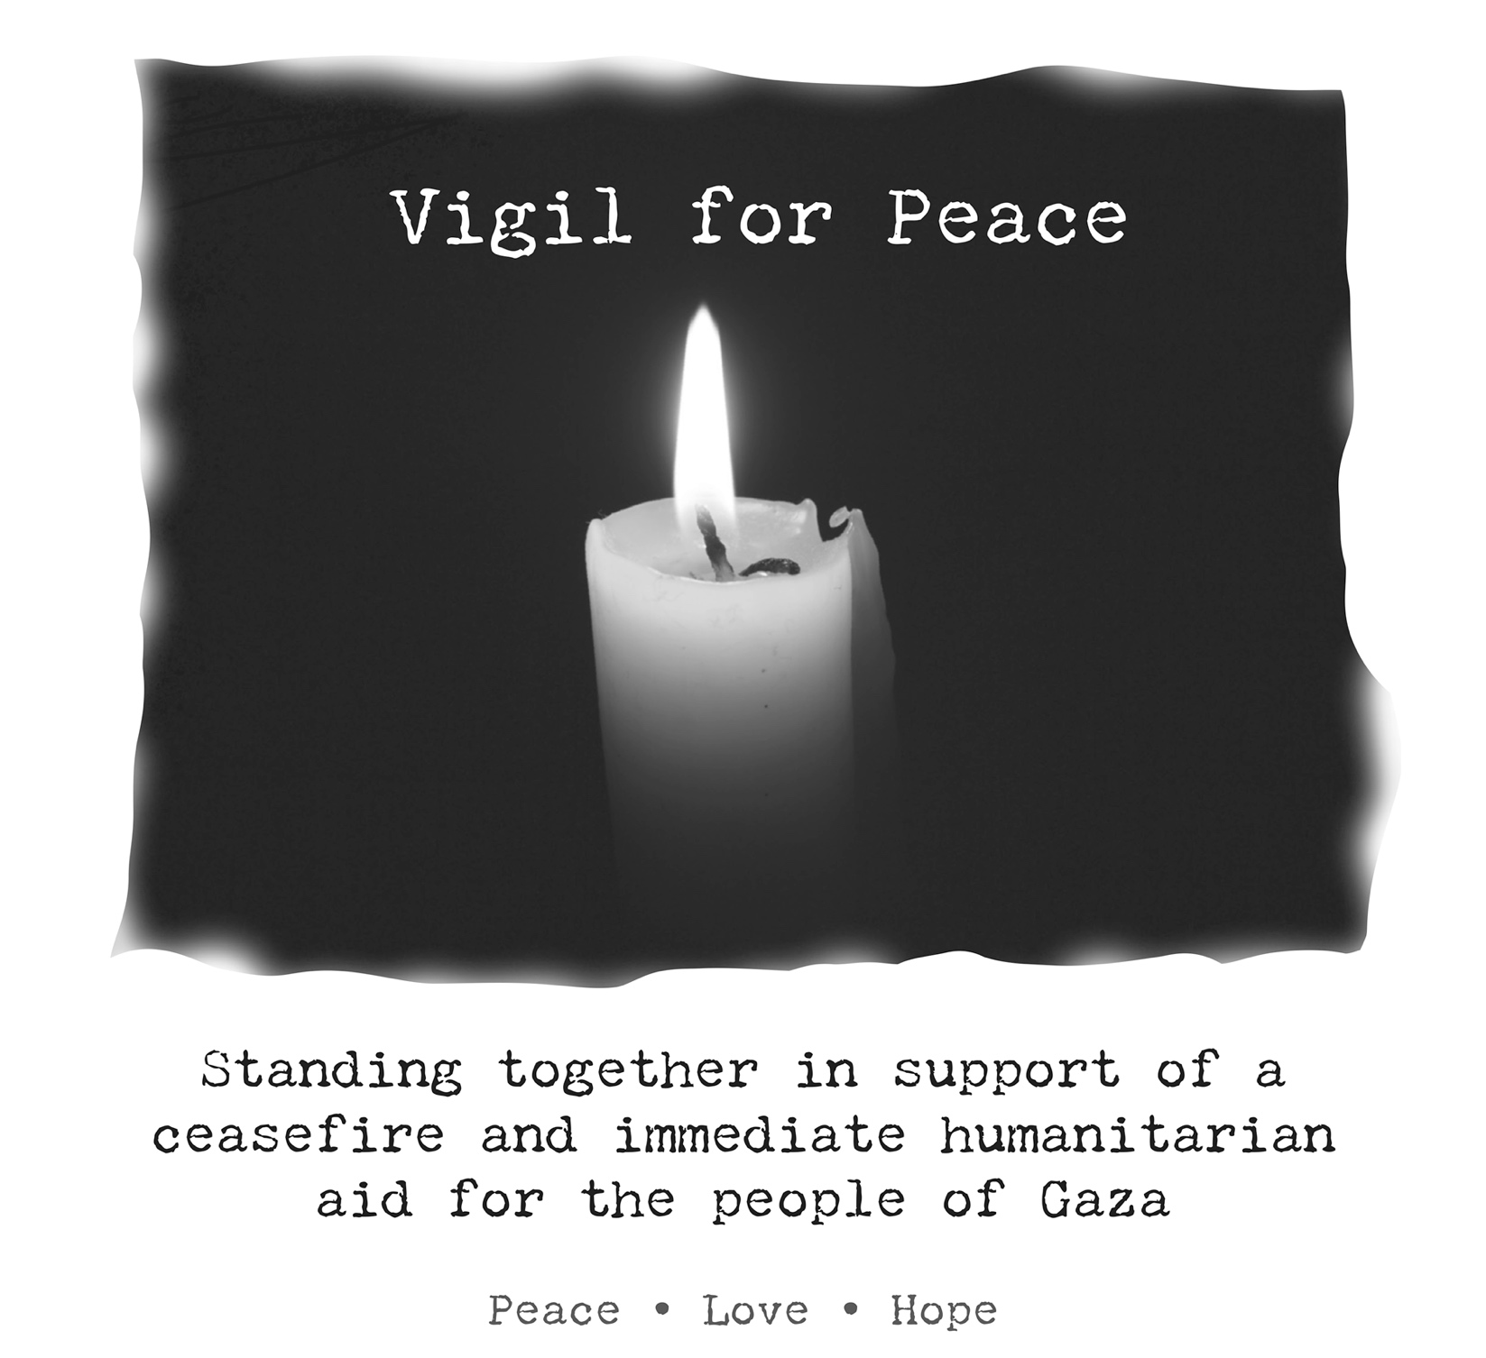

MEDIA RELEASE

2 November 2023

REFUGEE GROUPS CALL FOR IMMEDIATE CEASEFIRE AND PROTECTION FOR REFUGEES AND CIVILIANS IN GAZA
Rural Australians for Refugees calls upon the Australian government to act urgently to invoke an immediate ceasefire and the protection of refugees and civilians in Gaza.
Rural Australians for Refugees, a national grassroots advocacy movement with more than 70 groups across the country, begins a month of vigils and local actions today to honour and grieve for the lives lost since 7 October.
Dr. Paul Dalzell, president of Rural Australians for Refugees said,
“The world must act to prevent a worsening humanitarian and refugee crisis. We ask that the Australian government add its voice to international calls for an immediate ceasefire to halt the devastating loss of innocent lives including refugees and civilians.”
“It is vital that attacks on Jabalia and other refugee neighbourhoods stop and that humanitarian protections be strengthened so that aid can reach Gaza in sufficient quantities and to allow for evacuation of those who want to leave.”
“We abhor the suffering in Israel and in Gaza. We call on all parties to respect the United Nations charter and do everything necessary to protect the lives of civilians, none of whom chose this war.”
Rural Australians for Refugees sprang up in 2001 to call for more humane and transparent approaches to asylum seeker and refugee policy in Australia. Now with 70 groups and growing, RAR provides ongoing support to refugee families and communities affected by the suffering of war.

Contact:
Reverend Dr D. Paul DALZELL, RAR President, 0467682036, rar.australia@gmail.com
Sandy Watson, RAR Communication Convenor, 0401 714 880, rartrentham@gmail.com

