Refugee Sector Letter Kit
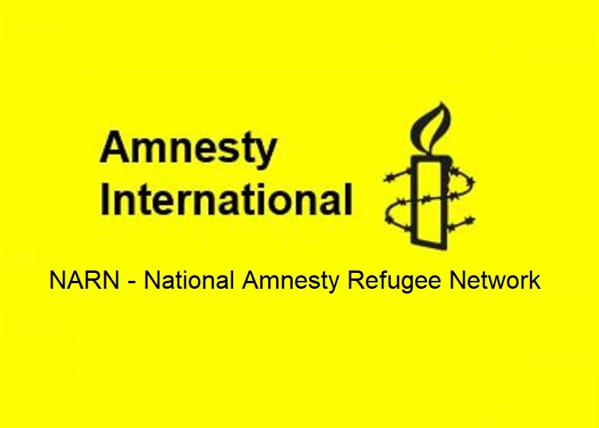

Supported by ARAN, RAR, GFR, & NARN
Issue for October 2023
Bring them to safety NOW

Available to download at –
- https://aran.net.au/resources/letter-writing/
- https://ruralaustraliansforrefugees.org.au/write-a-letter

Image: Refugee Action Coalition Sydney RAC and Refugee Action Collective (Victoria)

Included in this kit is the information you need to create your own letters or use the proformas

- Guide and Background notes prepared by ARAN’s Letter Writing Network.
- Postal Addresses for MPs and Senators
- Email addresses for MPs and Senators
- A proforma letter that you can copy (and personalise) to send by post or email.

Personalised letters are best –

- You might like to use the AIDA principle

  - A - Attention - grab the recipient's attention. Say something positive about the reader that is directed towards the focus of your letter. Stimulate the recipient's curiosity
  - I - Interest & Information - encourage the recipient to read on.
  - D - Desire - Getting the reader to want to do what you are seeking - in their interest to do so.
  - A - Action - inform the reader of the action you want them to take.

~~~~~~~~~~~~~~~~~~~~~~~~~~~~~~~~~~~~~
Regards,
The ARAN Letter Writing Network
austrefugeenetwork@gmail.com

Why it is important to write on this issue now

Crisis situation for refugees in PNG – bring them to safety NOW

- The situation is urgent - the refugees and people seeking asylum in PNG are being evicted from accommodation right now. Their essential services are also being cut off. Port Moresby is one of the most dangerous cities in the world – these men are vulnerable and at risk.

- It is understood that Australia is still funding the PNG Government, but the service providers state they have not been paid for over 12 months.

- Where is the money? Media reports in July 2023 revealed rorts and significant corruption associated with Australian funding provided to support offshore detention in PNG and Nauru, and the Albanese government committed to setting up a Parliamentary Inquiry.

- Australia is ultimately responsible for these people. They MUST be brought to safety in Australia immediately.

Background Information

Since taking office, the Labor Government has committed to dealing with the complex issue of those seeking Australia’s protection by giving expression to the values of compassion, justice, human rights, fairness and generosity.

However, the treatment of those still held in PNG is far from these ideals:

- Australia was responsible for sending hundreds of refugees to Manus Island (PNG) to be detained between 2012 and 2017. There are still about 60 men left in PNG, almost all of them now in Port Moresby

- Some of these men have the possibility of resettlement in a third country (US, Canada or NZ)

- Some have no possibility of getting out either because they are too ill to lodge (or follow up on) an application process, or because they are unable to be settled in the US, Canada or NZ

- Most of these men have severe medical or physical conditions, or both. They are unable to take care of themselves. They do not have the skills to live independently, let alone work – in PNG.

- The health care available to them is inadequate or non-existent

- There have been regular accounts of violence and fear tactics used against the (ex-Manus) men. Many have been assaulted and robbed

- Port Moresby is not safe for vulnerable people -

  - Walking after dark is particularly dangerous in Port Moresby. - UK Travel Advice

  - Do not travel alone, especially after dark. - Canadian Travel Advice

  - Risk of violent crime and sexual assault in PNG is high. Criminals often use 'bush knives' (machetes) and guns (including home-made ones). Always be alert to your surroundings. Avoid going out after dark. - Australian Travel Advice

- According to a variety of substantiated reports, a crisis is developing at this very moment in Port Moresby. ‘Refugees depending on the PNG Government for accommodation in at least nine separate properties in Port Moresby have already been evicted or warned that eviction is imminent.”
(ASRC Media Release 28 September 2023)

- To date there is no apparent progress in setting up the Parliamentary Inquiry into corruption associated with offshore funding which was announced in July

Sources

ASRC media release:
- https://asrc.org.au/2023/09/28/serious-concern-over-crisis-unfolding-for-refugees-in-png/

The Age and SMH: Refugees in PNG face eviction:
- https://www.theage.com.au/national/refugees-in-png-face-eviction-as-australian-taxpayers-dollars-dry-up-20230927-p5e85k.html

Guardian Australia: Refugees in PNG told they will be evicted after Australian-sponsored housing bills not paid
- https://www.theguardian.com/australia-news/2023/sep/29/papua-new-guinea-refugees-evictions-unpaid-bills-rent

Guardian Australia: PNG threatens to send refugees back to Australia:
- https://www.theguardian.com/australia-news/2023/oct/07/png-threatens-to-send-refugees-back-to-australia-unless-it-pays-up-to-48m-in-expenses

RCOA: Refugee Council of Australia renews calls for a royal commission into offshore detention contracts:
- https://www.refugeecouncil.org.au/royal-commission-offshore-detention-contracts/

RCOA: Pain continues in PNG 10 years on:
- https://www.refugeecouncil.org.au/pain-continues-in-png-ten-years-on/

UK Travel Advice:
- https://www.gov.uk/foreign-travel-advice/papua-new-guinea/safety-and-security

Canadian Travel Advice:
- https://travel.gc.ca/destinations/papua-new-guinea

Australian Travel Advice:
- https://www.smartraveller.gov.au/destinations/pacific/papua-new-guinea

ARAN - Refugees Off PNG campaign
- https://aran.net.au/campaigns/offshore-detention/#offPNGNauru

Refugees still stranded in PNG - Jason Siwat, Catholic Bishops Conference, PNG - YouTube
- https://www.youtube.com/watch?v=Ymp3SHQn97U

Who to Write to

- Prime Minister, Anthony Albanese

Send Copies to
- Attorney General, Mark Dreyfus
- Foreign Minister, Penny Wong
- Minister for Home Affairs, Clare O’Neil
- Minister for Immigration, Andrew Giles
- Your local MP
- Labor and Independent Senators in your State

Addresses for your letters: We are asking people to write to ALP and Independent politicians

Canberra Postal Address for all Senators
PO Box 6100
Senate,
Parliament House
Canberra ACT 2600

Canberra Postal Address for all MPs
PO Box 6022
House of Representatives
Parliament House
Canberra ACT 2600

Find electorate postal and email addresses for your local Labor MP here: https://www.aph.gov.au/senators_and_members/members

Prime Minister
The Hon Anthony Albanese, Prime Minister
PO Box 6022, House of Representatives, Parliament House, Canberra ACT 2600
or … use the contact form: https://www.pm.gov.au/contact-your-pm

Email Addresses for ALL Senators - updated June 2023
NB - For your convenience - Labor Party Senators are listed in RED

Email addresses for all ACT senators - ready to copy and paste into “TO” section of your email:
senator.katy.gallagher@aph.gov.au; Senator.David.Pocock@aph.gov.au

Email addresses for all NSW senators - ready to copy and paste into “TO” section of your email:
senator.ayres@aph.gov.au; senator.bragg@aph.gov.au; senator.cadell@aph.gov.au;
senator.davey@aph.gov.au; senator.faruqi@aph.gov.au; senator.hughes@aph.gov.au;
senator.kovacic@aph.gov.au; senator.mcallister@aph.gov.au; senator.oneill@aph.gov.au;
senator.payne@aph.gov.au; ; senator.sheldon@aph.gov.au; senator.shoebridge@aph.gov.au

Email addresses for all NT senators - ready to copy and paste into “TO” section of your email:
Senator.McCarthy@aph.gov.au; senator.nampijinpaprice@aph.gov.au

Email addresses for all Queensland senators - ready to copy and paste into “TO” section of your email:
senator.allman-payne@aph.gov.au; senator.canavan@aph.gov.au; senator.chisholm@aph.gov.au;
senator.green@aph.gov.au; senator.hanson@aph.gov.au; senator.mcdonald@aph.gov.au;
senator.mcgrath@aph.gov.au; senator.rennick@aph.gov.au; senator.roberts@aph.gov.au;
senator.scarr@aph.gov.au; senator.waters@aph.gov.au; senator.watt@aph.gov.au

Email addresses for all SA senators - ready to copy and paste into “TO” section of your email:
senator.antic@aph.gov.au; senator.birmingham@aph.gov.au; senator.farrell@aph.gov.au;
senator.fawcett@aph.gov.au; senator.grogan@aph.gov.au; senator.hanson-young@aph.gov.au;
senator.liddle@aph.gov.au; senator.mclachlan@aph.gov.au; senator.pocock@aph.gov.au;
senator.ruston@aph.gov.au; senator.marielle.smith@aph.gov.au; senator.wong@aph.gov.au

Email addresses for all Tasmania senators - ready to copy and paste into “TO” section of your email:
senator.askew@aph.gov.au; senator.bilyk@aph.gov.au; senator.carol.brown@aph.gov.au;
senator.chandler@aph.gov.au; senator.colbeck@aph.gov.au; senator.duniam@aph.gov.au;
senator.lambie@aph.gov.au; senator.mckim@aph.gov.au; senator.polley@aph.gov.au;
senator.tyrrell@aph.gov.au; senator.urquhart@aph.gov.au; senator.whish-wilson@aph.gov.au

Email addresses for all Victorian senators - ready to copy and paste into “TO” section of your email:
senator.babet@aph.gov.au; senator.ciccone@aph.gov.au; senator.henderson@aph.gov.au;
senator.hume@aph.gov.au; senator.mckenzie@aph.gov.au; senator.paterson@aph.gov.au;
senator.rice@aph.gov.au; senator.stewart@aph.gov.au; senator.thorpe@aph.gov.au;
senator.van@aph.gov.au; senator.walsh@aph.gov.au; senator.white@aph.gov.au

Email addresses for all WA senators - ready to copy and paste into “TO” section of your email:
senator.brockman@aph.gov.au; senator.cash@aph.gov.au; senator.cox@aph.gov.au;
senator.dodson@aph.gov.au; senator.lines@aph.gov.au; senator.matt.o'sullivan@aph.gov.au;
Senator.Payman@aph.gov.au; senator.pratt@aph.gov.au; senator.reynolds@aph.gov.au;
senator.smith@aph.gov.au; senator.steele-john@aph.gov.au; senator.sterle@aph.gov.au

NOTE: If you are sending an email be sure to include your NAME and ADDRESS
The Subject line of your email could be - CALL TO ACTION - Bring them to safety NOW

Sample letter

Date
The Prime Minister, Anthony Albanese
PO Box 6022
House of Representatives
Parliament House
Canberra ACT 2600

Dear Prime Minister
The situation for the refugees left in Port Moresby, PNG, is unravelling rapidly. It is now at crisis point.

Reports in Australia’s media tell of people cut off from critical support and evicted from their accommodation.
These extremely vulnerable people have already suffered human rights abuses, medical neglect, violence and assaults, family separation and never-ending uncertainty. They are now at extreme risk of further violence, of homelessness and destitution.

Australian governments have spent millions of dollars to look after these refugees and asylum seekers in PNG. Yet a veil of secrecy surrounds everything to do with both the money and the deals done by the Australian and the PNG governments. Service providers in PNG claim the money has dried up. The Australian Government has refused to disclose financial or contractual details. We know that contracts worth millions were marred by suspect payments in Nauru and PNG to politicians, officials and contractors. The promised Parliamentary Inquiry needs to be set up as a priority before millions more go missing.

Australia IS responsible for these people.

  - Australia sent them to PNG.
  - Their treatment under Australian immigration detention in PNG has damaged them grievously.
  - The Coalition government made a financial deal with PNG to enable Australia to ostensibly revoke all responsibility for those people.
  - The current Labor government has a moral responsibility to revoke that deal, and act according to the principles Labor says it is committed to.

These vulnerable men must be brought to Australia immediately.

They must be given all necessary care within the community.

Yours sincerely

Your name and address

