Refugee Sector Letter Kit

Supported by ARAN, RAR, GFR, & NARN
Issue for September 2023
Implementing Labor’s Refugee Policies

Available to download at –
- https://aran.net.au/resources/letter-writing/
- https://ruralaustraliansforrefugees.org.au/write-a-letter

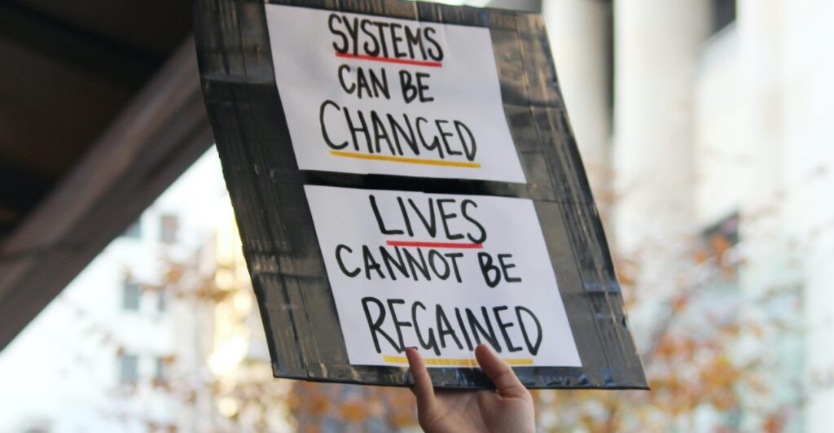

Included in this kit is the information you need to create your own letters or use the proformas

- Guide and Background notes prepared by ARAN’s Letter Writing Network.
- Postal Addresses for MPs and Senators
- Email addresses for MPs and Senators
- A proforma letter that you can copy (and personalise) to send by post or email.

Personalised letters are best –

- You might like to use the AIDA principle

  - A - Attention - grab the recipient's attention. Say something positive about the reader that is directed towards the focus of your letter. Stimulate the recipient's curiosity
  - I - Interest & Information - encourage the recipient to read on.
  - D - Desire - Getting the reader to want to do what you are seeking - in their interest to do so.
  - A - Action - inform the reader of the action you want them to take.

~~~~~~~~~~~~~~~~~~~~~~~~~~~~~~~~~~~~~
Regards,
The ARAN Letter Writing Network
austrefugeenetwork@gmail.com

Why it is important to write on this issue now
- The 2023 ALP Conference is over.
- Now we are asking ALP politicians to make good on their commitments at the Conference.
- PM Albanese describes his government as a government of action, one that wants to make a difference.
- At the conference there was a commitment to a number of changes, but there are no timeframes at this stage. It’s important that we demand swift action.

Background Information

In relation to refugees and people seeking asylum, two of the key commitments made at the Conference were:
- That the Labor government would …
- make every effort to remove people seeking asylum from immigration detention centres through community detention as soon as possible.
- grant bridging visas with work and study rights while people’s claims for protection are assessed.
- That the Labor government would …
- ensure people seeking asylum have access to appropriate, independent, government- funded legal advice while working through their claims for protection.
- Provide means-tested access to appropriate social services, including income, crisis housing, healthcare, mental health, education and English as a Second Language support during the assessment of protection claims.

Sample letter

Dear Ministers Giles
I have read with interest and some optimism a summary of commitments made regarding the treatment of refugees and people seeking asylum at the recent ALP National Conference.
While recognising that the implementation of these commitments will require time, I am concerned about unnecessary delays in implementing relatively simple changes, changes which would make the situation much more tolerable for people who are still awaiting determination of their claims after many years of uncertainty.
I am writing to ask that you to move quickly to make these long-awaited changes to:
- Grant work and study rights to all people on bridging visas, and those in lengthy appeals processes.
- Provide means-tested access to appropriate social services, including income, crisis housing, healthcare, mental health, education, and English as a Second Language support.
These changes will alleviate the fear of homelessness, and the indignity of begging for charity support.
Please take a stand for justice. The Labor Government must provide just and compassionate treatment of refugees and people who seek protection in Australia.

Yours sincerely

Your name and address

Addresses for your letters: This month we are asking people to write to ALP politicians

Canberra Postal Address for all Senators
PO Box 6100
Senate,
Parliament House
Canberra ACT 2600

Canberra Postal Address for all MPs
PO Box 6022
House of Representatives
Parliament House
Canberra ACT 2600

Find electorate postal and email addresses for your local Labor MP here: https://www.aph.gov.au/senators_and_members/members

Andrew Giles, Minister for Immigration
The Hon Andrew Giles MP, Minister for Immigration
PO Box 6022, House of Representatives, Parliament House, Canberra ACT 2600
or … Email: Andrew.Giles.MP@aph.gov.au

Email Addresses for ALL Senators - updated June 2023
NB - For your convenience - Labor Party Senators are listed in RED

Email addresses for all ACT senators - ready to copy and paste into “TO” section of your email:
senator.katy.gallagher@aph.gov.au; Senator.David.Pocock@aph.gov.au

Email addresses for all NSW senators - ready to copy and paste into “TO” section of your email:
senator.ayres@aph.gov.au; senator.bragg@aph.gov.au; senator.cadell@aph.gov.au;
senator.davey@aph.gov.au; senator.faruqi@aph.gov.au; senator.hughes@aph.gov.au;
senator.kovacic@aph.gov.au; senator.mcallister@aph.gov.au; senator.oneill@aph.gov.au;
senator.payne@aph.gov.au; ; senator.sheldon@aph.gov.au; senator.shoebridge@aph.gov.au

Email addresses for all NT senators - ready to copy and paste into “TO” section of your email:
Senator.McCarthy@aph.gov.au; senator.nampijinpaprice@aph.gov.au

Email addresses for all Queensland senators - ready to copy and paste into “TO” section of your email:
senator.allman-payne@aph.gov.au; senator.canavan@aph.gov.au; senator.chisholm@aph.gov.au;
senator.green@aph.gov.au; senator.hanson@aph.gov.au; senator.mcdonald@aph.gov.au;
senator.mcgrath@aph.gov.au; senator.rennick@aph.gov.au; senator.roberts@aph.gov.au;
senator.scarr@aph.gov.au; senator.waters@aph.gov.au; senator.watt@aph.gov.au

Email addresses for all SA senators - ready to copy and paste into “TO” section of your email:
senator.antic@aph.gov.au; senator.birmingham@aph.gov.au; senator.farrell@aph.gov.au;
senator.fawcett@aph.gov.au; senator.grogan@aph.gov.au; senator.hanson-young@aph.gov.au;
senator.liddle@aph.gov.au; senator.mclachlan@aph.gov.au; senator.pocock@aph.gov.au;
senator.ruston@aph.gov.au; senator.marielle.smith@aph.gov.au; senator.wong@aph.gov.au

Email addresses for all Tasmania senators - ready to copy and paste into “TO” section of your email:
senator.askew@aph.gov.au; senator.bilyk@aph.gov.au; senator.carol.brown@aph.gov.au;
senator.chandler@aph.gov.au; senator.colbeck@aph.gov.au; senator.duniam@aph.gov.au;
senator.lambie@aph.gov.au; senator.mckim@aph.gov.au; senator.polley@aph.gov.au;
senator.tyrrell@aph.gov.au; senator.urquhart@aph.gov.au; senator.whish-wilson@aph.gov.au

Email addresses for all Victorian senators - ready to copy and paste into “TO” section of your email:
senator.babet@aph.gov.au; senator.ciccone@aph.gov.au; senator.henderson@aph.gov.au;
senator.hume@aph.gov.au; senator.mckenzie@aph.gov.au; senator.paterson@aph.gov.au;
senator.rice@aph.gov.au; senator.stewart@aph.gov.au; senator.thorpe@aph.gov.au;
senator.van@aph.gov.au; senator.walsh@aph.gov.au; senator.white@aph.gov.au

Email addresses for all WA senators - ready to copy and paste into “TO” section of your email:
senator.brockman@aph.gov.au; senator.cash@aph.gov.au; senator.cox@aph.gov.au;
senator.dodson@aph.gov.au; senator.lines@aph.gov.au; senator.matt.o'sullivan@aph.gov.au;
Senator.Payman@aph.gov.au; senator.pratt@aph.gov.au; senator.reynolds@aph.gov.au;
senator.smith@aph.gov.au; senator.steele-john@aph.gov.au; senator.sterle@aph.gov.au

NOTE: If you are sending an email be sure to include your NAME and ADDRESS
The Subject line of your email could be - CALL TO ACTION - Implementing Labor’s Refugee Policies

